Case Study 2: Insurance Policy Administration System (Backend-Heavy)
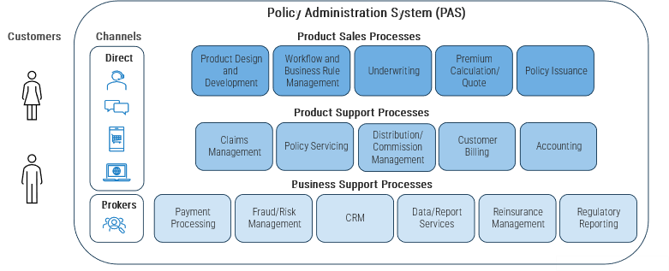
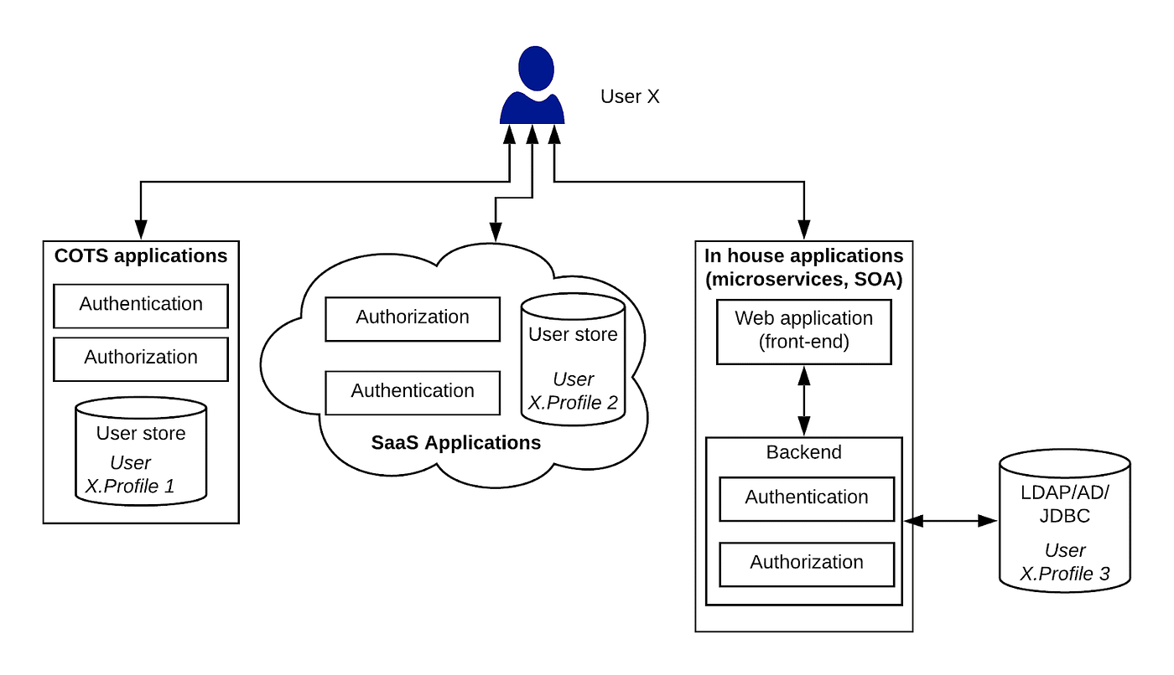
🏢 Company Context
- Health & life insurance provider
- Web portal built using:
  - JSP frontend
  - Heavy Java backend
- Frontend has almost no logic

🔧 Architecture Reality
Frontend:
- Simple forms
- Submit buttons
Backend:
- Eligibility checks
- Premium calculation
- Policy validation
- Business rules
- PDF generation

